A Closer Look:
Closing the Performance Gap

Donald D. Deshler
University of Kansas Center for Research on Learning



A Closer look: Closing the Performance Gap

Don Deshler, Director
University of Kansas Center for Research on Learning
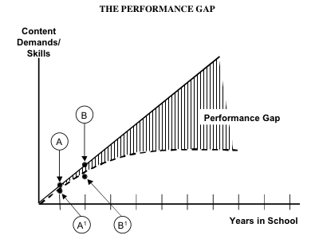
The problems that at-risk adolescents face when trying to succeed within the rigorous general education curriculum are great. Unless they have the necessary skills and strategies in place to respond to the heavy curriculum demands, they will encounter failure and significant frustration. Figure 1 illustrates the dilemma faced by teachers and students in today’s schools. The straight, solid line represents the path of “normal” acquisition of knowledge or skills by typical students. That is, at the conclusion of one year of instruction, on average, students should have acquired what would be deemed to be one year’s worth of skills and strategies that, in turn, would enable them to successfully respond to the demands of the curriculum for that grade. This is represented by point A on the straight line. At the end of the second year, assuming “normal skill and strategy acquisition,” they should be performing at the level of point B, and so on. In contrast, the performance of students who struggle in learning usually does not follow this path of progress. On average, these students perform at the level of point A¹ at the end of one year of schooling and travel a path similar to the one depicted by the dotted curved line. That is, because they fail to acquire skills and strategies at the rate that their normal-achieving peers do, they are unable to successfully respond to the grade-level curriculum demands. Hence, there is a discrepancy between their performance and that of their peers who have learned the expected skills and strategies needed to respond to the demands of the curriculum. The area between the solid line (representing normal acquisition of skills and strategies as well as the demands of the curriculum) and the dotted line (representing underachievement) depicts the “performance gap,” the gap between what students are expected to do and what they can do. Over time, this gap grows larger and larger, and it is especially exacerbated in the later grades, when the academic growth of at-risk students plateaus. As a result of this performance gap, these students are unable to meet the demands of required courses in the content areas in high school, and their resulting failure leads to discouragement and disengagement in school.
Figure 1
For years, CRL has used the “performance gap” as a framework for trying to understand the challenges that struggling adolescent learners face and to conceptualize ways to improve their academic outcomes. Historically, we have explained how two of the major lines of CRL research (namely, learning strategy interventions and content enhancement routines) can work together to help close this gap. That is, on the one hand, learning strategy interventions have been designed to change students as learners by teaching them how to learn. As students master an array of learning strategies, it is hoped that the trajectory of the curved line (which represents student achievement in relation to curriculum demands) will move closer to the straight line. The content enhancement routines, on the other hand, have been designed to change how teachers think about, select, and present critical subject matter information to students. Consistent use of these routines has been shown to make the subject matter easier to understand and to remember.
Moving beyond the original performance gap framework
Although this framework has been useful, the new realities that schools face today as a result of adequate yearly progress (AYP) requirements called for by the No Child Left Behind Act have underscored some of its limitations. As currently conceptualized, this framework lacks the power to adequately explain all of the factors that must be taken into account by teachers and administrators to truly close the gap. To this end, we have adopted a new model to guide our thinking as researchers and our actions as change agents working in schools. The goal of this new framework is to provide a tool that is sufficiently broad in its scope to identify those variables that need to be addressed to optimize our chances of dramatically improving the performance of struggling adolescent learners.
The new framework
As shown in Figure 2, the new framework ties improved student outcomes to two critical factors: (1) an instructional core (which is primarily related to high quality teaching), and (2) an infrastructure core (which is primarily related to strong administrative leadership). As will be seen shortly, all of the interventions and instructional practices that we have come to associate with the Strategic Instruction Model (SIM) are present within these two core factors. However, other critical elements have been included within both the instructional and infrastructure cores that we now consider to be essential to achieving significant student outcomes. Among the outcomes that should be used to measure the effectiveness of our efforts are the following:
• Reading (and other learning) proficiency
• Improved attendance
• Persistence in school
• Challenging courses
• Graduation

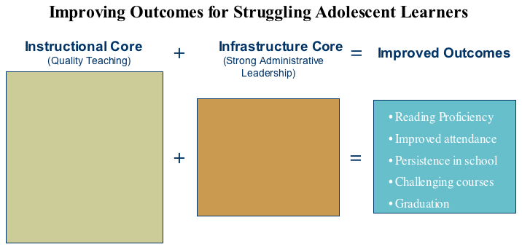
Figure 2

It is important to note that the first core depicted in Figure 2 and discussed below is the instructional core. This is not by accident. Historically, the vast majority of initiatives aimed at improving secondary schools have focused on non-instructional factors (e.g., moving to block scheduling, changing from a middle school to a junior high school configuration, etc.). The prevailing assumption has been that the quickest and most effective way to improve student outcomes was to change infrastructural factors. Instruction, if considered at all, was largely an afterthought in most secondary school improvement efforts. CRL’s research, however, has clearly underscored the vital role of high quality instruction in improving student achievement. Hence, this framework thinks of and specifies the instructional core first. In light of what is required to provide high quality instruction, the infrastructure core is then chosen and used to support the instructional needs. In other words, “form follows function”! Regrettably, most school improvement efforts have first changed the structure and then expected instructional practices to conform to the new structure (whether it made pedagogical sense or not)!
The instructional core consists of five elements and the infrastructural core of four. These elements should not be seen as isolated elements in an inventory of potential elements, but rather as a group in which elements have a dynamic and powerful interrelationship. As we conduct additional research, we expect to better understand the relative power of each of these elements and the optimal mix that needs to be in place for different types of schools and instructional circumstances.
The instructional core
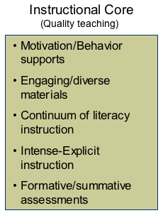
Figure 3 depicts the five key elements in the instructional core. Each is seen as being essential to creating an ideal set of instructional conditions.
Figure 3
Motivation/positive behavior supports. To optimally capitalize on the limited amount of instructional time available to closing the performance gap, we must first create a learning environment in which students can be fully engaged in productive academic work. A 2004 study titled Teaching Interrupted notes that 77 percent of secondary teachers report significant behavioral disruptions occur in their classrooms that markedly affect their ability to provide effective instruction. Of equal concern is the large number of adolescents who are disengaged and unmotivated. Before we can be successful in teaching critical content or strategies to students, we must take steps to create a positive and productive environment for learning. To this end, CRL has formed a formal partnership with Randy Sprick, who has created a broad array of classroom and school-based systems for creating productive academic environments. All of his programs are based on positive behavioral support principles. (An interview with Randy appeared in the May 2004 issue of Stratenotes, Vol. 12, No. 8; an extended version is available on our web site at www.kucrl.org/archives/.) Similarly, the sole purpose of our research in the area of Possible Selves has been to validate procedures that teachers can effectively leverage to engage and motivate students.
Engaging/diverse materials. One of the greatest challenges facing those who work with struggling adolescent learners is finding ways to make learning relevant to their lives and sufficiently engaging that students will choose to invest themselves in the learning process. To become skilled and fluent learners, these students need ample opportunities to practice applying newly learned skills and strategies. To accomplish this, they need access to a rich array of reading materials that are engaging and diverse. Too often, students become frustrated when they are forced to read materials that are well beyond their skill level or that hold little interest for them. Instructional materials should:
• Be below students’ frustration level
• Be responsive to a wide range of student abilities
• Cover a broad array of engaging topics
• Be relevant to students’ backgrounds (SES, culture, etc.)
These first two elements—motivation/positive behavior supports and engaging/diverse materials—are listed first in this section for a simple reason: These elements are vital to “hook” students. Without fostering student interest and engagement, other instructional reforms will likely lack effectiveness.
Continuum of literacy instruction. To bring about dramatic changes in the state of adolescent literacy, significant changes are required in (a) how secondary teachers see their role in teaching literacy, and (b) how basic literacy skills should be considered as an integral part of the secondary school curriculum. Because of the broad array of student needs and the complexity of the problems presented by adolescents with poor literacy skills, no single program or approach can meet the needs of all. Thus, the best adolescent literacy programs are ones that consider both the unique needs of students with literacy problems and the realities of secondary schools. Some students will need more individualized, explicit, intensive instruction of basic literacy skills, while other students will need opportunities to practice fluency and comprehension skills within the context of their regular classes. Others might need extended day tutoring in before- and after-school achievement centers. In short, it is important to meet students where they are in their literacy development.
A continuum with five different levels has been conceptualized to be responsive to the needs of struggling adolescents. We’ve called this continuum the Content Literacy Continuum (CLC). Additionally, since the problems of adolescents with literacy problems are so significant, intervention outside of the school day may be warranted. Hence, secondary schools should consider the important role that before- and after-school tutoring programs can play to support services provided across the Content Literacy Continuum. The following is a synopsis of the five levels:
Level 1: Enhance content instruction (mastery of critical content for all regardless of literacy levels)
Level 2: Embedded strategy instruction (routinely weave strategies within and across classes using large group instructional methods)
Level 3: Intensive strategy instruction (mastery of specific strategies using eight-stage instructional sequence; individual Strategic Tutoring)
Level 4: Intensive basic skill instruction (mastery of entry-level literacy skills at the fourth-grade level)
Level 5: Therapeutic intervention (mastery of language underpinnings of curriculum content and learning strategies)
Intense-explicit instruction. CRL researcher Jim Knight concisely defined the nature and purpose of intensive-explicit (IE) instruction for at-risk learners. Specifically, IE instruction refers to a set of instructional procedures that together efficiently and effectively enable teachers to convey content clearly to students in a manner that leads to students mastering information. IE is intensive because it involves teaching practices that ensure students are engaged in learning and actively mastering content. IE is explicit because it involves teachers clearly modeling covert thinking and providing detailed feedback as students move toward mastery of content. A primary goal of IE instruction is for students to understand, remember, and generalize content taught by a teacher. Simply put, instructors use IE instruction so that students will have a picture of knowledge in their heads that is similar to the picture teachers have in their heads. IE instruction uses most of the following instructional stages to achieve this goal: describe, model, vocabulary memorization, practice and feedback, and generalization.
Formative and summative assessments. At the core of quality teaching are data that profile the strengths and weaknesses of students on key learning targets. These data enable teachers to make adjustments in the instructional process to better meet student needs. In the absence of these data, students’ progress can be stifled and progress slowed or stopped altogether. Summative data tell teachers and students whether educational goals have been met at the end of a specified period.
When all of the elements of the instructional core are in place, considerable progress can be made in closing the performance gap, as shown in Figure 4.

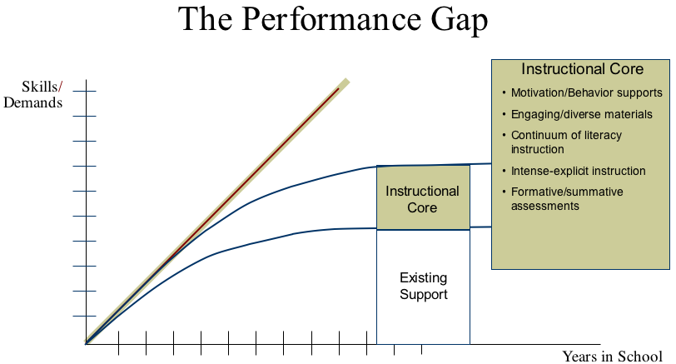
Figure 4
The infrastructure core
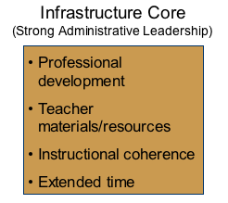
Figure 5 shows the elements embodied in the infrastructure core. Generally speaking, these elements are ones that are a function of strong administrative leadership—certainly at the building level but often from central administration, as well. As argued above, school improvement should, first and foremost, be driven by the instructional core; however, if these infrastructure elements are not present, much of the power represented by changes in the instructional core will be minimized. A critical role played by the building principal is to communicate and help all staff embrace a shared vision of a school-wide approach to addressing the literacy problems of its students.
Figure 5
Professional development. Professional development grounded in the principles embraced by the SIM Professional Development Network is essential in supporting teachers in the acquisition and effective application of research-based practices from SIM. In short, the professional development must be focused, sustained, data driven, personalized, designed to create a learning community, and about system change. Additionally, it must provide to teachers ample opportunities to practice and receive feedback on the new practice and to receive continuing coaching to support the refined and sustained application of the innovation.
Teacher materials and resources. Quality instruction of research-based practices is dependent, in large measure, on teachers being supplied the appropriate support materials required to deliver their instruction. At a minimum, this consists of well-designed teacher manuals, student learning sheets and activities for practice, scoring rubrics that enable high-quality feedback to be provided, and the necessary technology supports, such as tape recorders, DVDs, or computers. CRL’s longstanding commitment to developing teacher manuals and other instructional supports underscores the importance of this element.
Instructional coherence. One of the greatest challenges that struggling adolescents and their teachers face in secondary schools is the problem of “fragmentation.” That is, because the school day is structured around class periods and each student having multiple teachers, they generally experience an instructional program that is much more fragmented than what they experienced in elementary school. In elementary school, most students have one teacher throughout the entire day; this fact alone greatly reduces fragmentation in learning. This can best be understood with an example. If a third-grade teacher teaches a given skill in the morning, she can emphasize that skill throughout the course of the day and capitalize on natural teaching moments when the targeted skill can be showcased when opportunities surface during the day. She has an understanding of the whole picture of a given student’s educational program and can provide coherent, well-integrated instruction to that student. In secondary school settings, there is often little, if any, planning or orchestration across teachers. Thus, if a teacher in the first period teaches a skill, it is highly unlikely that that skill will be reinforced at any time throughout the day by other teachers simply because they are unaware of what is taught by their colleagues. Hence, relative to the instruction of critical skills, strategies, and content elements, secondary schools are very fragmented and lack coherence. To avoid this dilemma, principals need to promote shared planning times and class configurations that promote reinforcement of what is taught across teachers, classes, and schools.
Extended time. Because of the magnitude of the performance gap, students need sufficient time to receive high-quality instruction in deficit areas and to have ample time to practice the skills and strategies they are lacking. Regrettably, in secondary schools, there generally isn’t a “reading class,” per se. This problem needs to be addressed. Educational leaders in schools that are having the most success with struggling adolescent learners find ways to create increased time for literacy instruction. In the absence of this challenge being addressed, it is highly unlikely that the gap will be closed. As a part of the solution, some schools have included before- and after-school tutoring programs.
Conclusion
Closing the large performance gap that many struggling adolescent learners face is a daunting task. The challenge will not be addressed through token efforts or minimizing or neglecting any of the items detailed above. The solution requires major changes and investments on both the instructional and infrastructure fronts. In addition to these factors, it is important also to remember the important role that families, out-of-school organizations, and other community supports can play in bolstering adolescent literacy programs. The resulting new framework for closing the performance gap is shown in Figure 6.

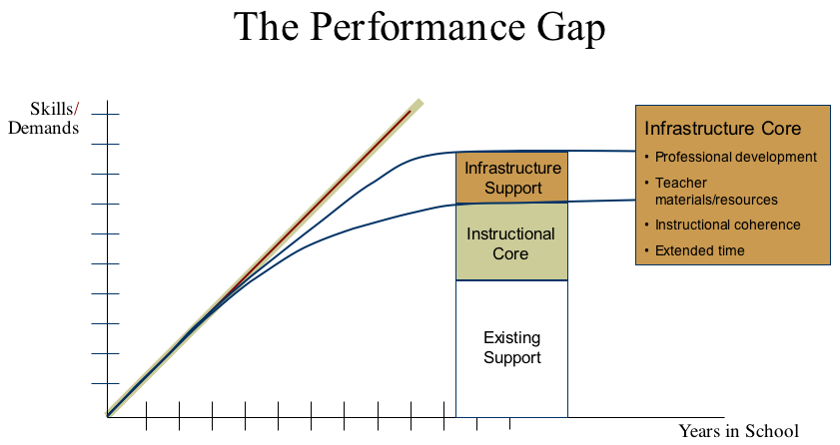
Figure 6

The recently released report by the Carnegie Corporation of New York on adolescent literacy titled Reading Next: A Vision for Action in Middle and High School Literacy was influenced by CRL researchers and, in turn, has influenced our thinking about how to best close the performance gap. The complete report can be downloaded from www.all4ed.org.

